**ABYSS**

**TRACKING ACTIVITY AND PROJECT MANAGAMENT**

**SYSTEMS ANALYSIS & DETAILED DESIGN**

**SSYADD SS201**

**BSCS-SS201**

**Mr. Jayvee Cabardo**

Client

**Mr. Jose Eugenio Quesada**

Subject Professor

**SY 2022-2023**

**Group Members**

Leader

**Noreen Keziah Sioco**

Members

**Bea Angeline Cruz**

**Mark Gerald Giba**

**Joseph Adrian Lebag**

**Jose Norberto Verde**

1. **DATA FLOW DIAGRAMS (Level 0, Level 1, Level**

**Level 0**

**Level 1**

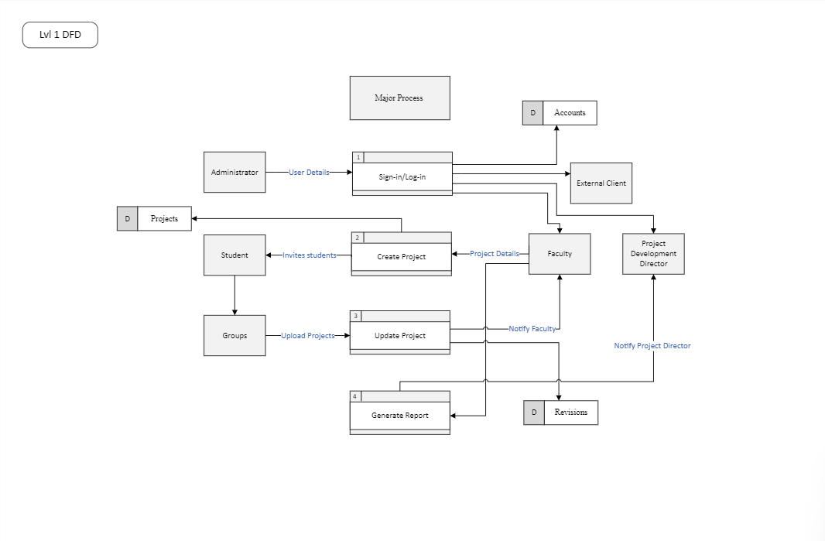

**Level 2**

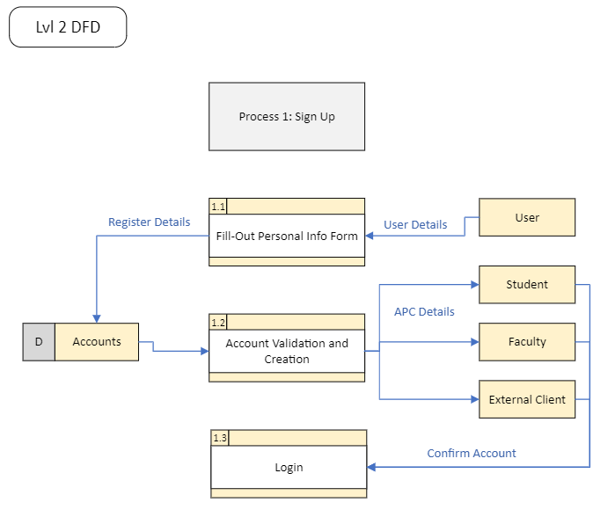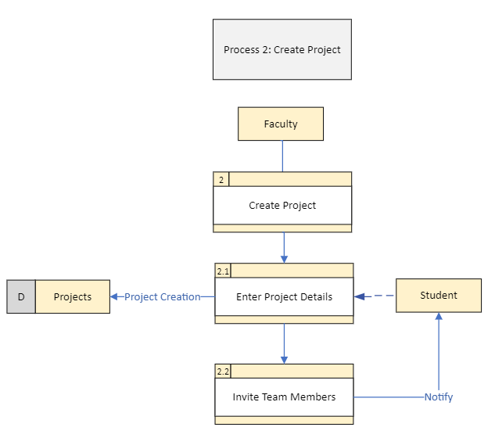

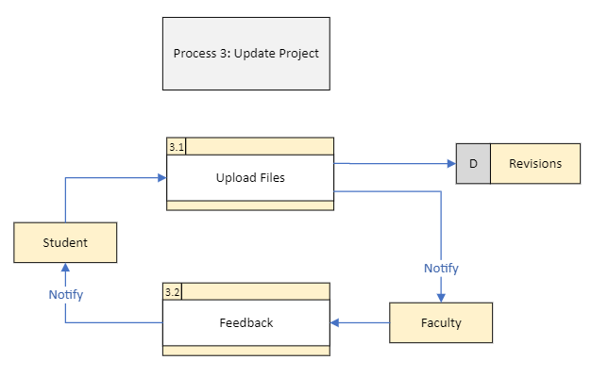

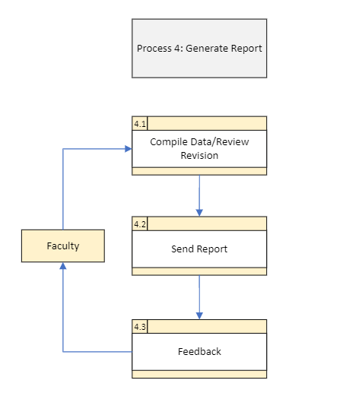

1. **Use Case**
   1. **Use Case Diagrams**
2. **Diagrams**

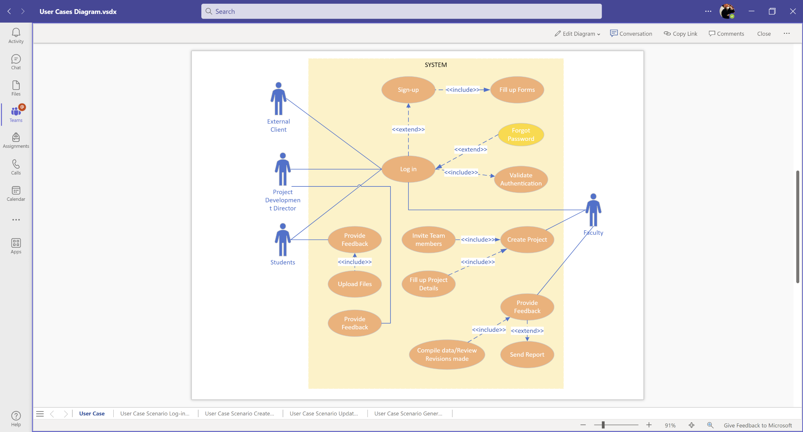

1. **Use Case fully Dressed**

Brief Format

**Sign Up:** The User will fill up user details to sign up.

**Login:** TheUser will fill up user details and the system will authenticate users access to the system.

**Create Project**: The faculty will fill up project details to create a project. The faculty will invite the students to create a project in a group within the created project page. The assign group will upload the projects.

**Update Project:** The faculty will review/ check the uploaded projects and revisions made by the group. The faculty will compile the revisions done by the group.

**Generate Report:** The faculty will report/ notify the project development director about the revisions done by the group. The faculty can wait for the feedback of the project development director about the projects done by the group.

Casual Format

**Sign Up:** The User will fill up user details to sign up or register.

*Alternate Scenario:*

If the user that will sign up is an external client and does not have an APC email, the user will have to use business or personal email.

If the user is part of APC, then the system will validate the credential against the APC database.

**Login:** TheUser will fill up user details and the system will authenticate users access to the system.

*Alternate Scenario:*

If the user does not have an APC account, the user will sign up or register.

If the user enters the wrong username the system will return a message.

If the user enters the wrong password the system will display “Wrong Password.”

**Create Project**: The faculty will fill up project details to create a project. The faculty will invite the students to create a project in a group within the created project page. The assign group will upload the projects.

*Alternate Scenario:*

If the student failed to receive the invite, the student will email the faculty.

If a group updated their project the faculty will be notified. The faculty will review and give feedback to the group

If the faculty thinks the project needs work, the group will revise the project.

**Update Project:** The faculty will review/ check the uploaded projects and revisions made by the group. The faculty will compile the revisions done by the group.

*Alternate Scenario:*

If the revisions done by the students are approved, the faculty will notify the student.

If the revision of the project did not meet the deadline, the student group should notify the faculty.

**Generate Report:** The faculty will report/ notify the project development director about the revisions done by the group. The faculty can wait for the feedback of the project development director about the projects done by the group.

*Alternate Scenario:*

If the project development director gives feedback about the project, the faculty should notify the student group about it.

Fully Dressed

|  |  |
| --- | --- |
| **Use Case Name** | Login |
| **Scenario** | User wants to log into their Account |
| **Triggering Event** | Student/Faculty/Project Director/Client clicks on the login button |
| **Brief Description** | Student/Faculty/Project Director/Client use login |
| **Actors** | Student, Faculty, Project Director, Client |
| **Related Use Cases** | Sign up |
| **Stakeholders** | Student, Faculty, Project Director, Client |
| **Preconditions** | User must know the System URL to login  A user can login with APC (Asia Pacific College) Account  Outside clients must sign up first |
| **Postconditions** | User has logged in  Show success/error message |
| **Flow of Activities** | Actors   * Users will log in using their APC email.   System   * The system will then direct them to the homepage of the application. |
| **Exception Conditions** | Wrong password/wrong credentials |

|  |  |
| --- | --- |
| **Use Case Name** | Sign up |
| **Scenario** | A client wants to register an account |
| **Triggering Event** | Client clicks on the register button |
| **Brief Description** | Client registers for an access account |
| **Actors** | Student, Faculty, Project Director, Client |
| **Related Use Cases** | Login |
| **Stakeholders** | Student, Faculty, Project Director, Client |
| **Preconditions** | Client will click the Sign-up button at the Login page  Client will enter personal details and information |
| **Postconditions** | Client will click the create button  Show success/error message |
| **Flow of Activities** | Actors   * The users will enter their email address and password. * The users will receive a verification code to confirm their email address.   System   * The system will send a verification code. * The system will then direct the users to the homepage of the application after signing up. |
| **Exception Conditions** | If the user that will sign up is an external client and does not have an APC email, the user will have to use business or personal email.  If the user account is a faculty member, student, project development director or external client, the system will authenticate it. |

|  |  |
| --- | --- |
| **Use Case Name** | Create Project |
| **Scenario** | Faculty wants to create a project |
| **Triggering Event** | Faculty clicks the create button |
| **Brief Description** | Faculty creates project for students per group |
| **Actors** | Faculty, Student, Client |
| **Related Use Cases** | Update Project |
| **Stakeholders** | Faculty, Student |
| **Preconditions** | The client will create a project. |
| **Postconditions** | The students will then access the project. |
| **Flow of Activities** | Actors   * Faculty/Client will create a project. * Faculty/Client will assign the project to the student groups.   System   * The system will create the project. * After the system created the project, it will also have a collaborative link that can be accessed by the students. |
| **Exception Conditions** | If the student failed to receive the invite, the student will email the faculty.  If a group updated their project the faculty will be notified. The faculty will review and give feedback to the group |

|  |  |
| --- | --- |
| **Use Case Name** | Update Project |
| **Scenario** | Student wants to revise a project |
| **Triggering Event** | Student clicks the update button |
| **Brief Description** | The student will update the projects according to the feedback of the client and faculty. |
| **Actors** | Faculty, Student, Client |
| **Related Use Cases** | Create Project |
| **Stakeholders** | Faculty, Student, Client |
| **Preconditions** | Faculty/client will send feedbacks about the project.  Students will revise the project according to the faculty/client feedback. |
| **Postconditions** | The daily scrum bot that the application has will send notifications about the latest updates of the project. |
| **Flow of Activities** | Actors   * The client/faculty will send feedback about the project to students. * The students will then update the project regarding with the client/faculty feedback.   System   * The system will send a notification with the help of our daily scrum bot about the revisions regarding the project. |
| **Exception Conditions** | If the revisions done by the students are approved, the faculty will notify the student.  If the revision of the project did not meet the deadline, the student group should notify the faculty. |

|  |  |
| --- | --- |
| **Use Case Name** | Generate Report |
| **Scenario** | Faculty/Client want to send feedback |
| **Triggering Event** | User clicks the feedback button |
| **Brief Description** | When the students are done with the project the client/faculty will then generate a report about the project in progress. |
| **Actors** | Faculty, Client, Project Director |
| **Related Use Cases** | Update Project |
| **Stakeholders** | Faculty, Client, Project Director |
| **Preconditions** | The students will send the paper to the faculty/client for feedback. |
| **Postconditions** | The client will send the feedback for the paper  The daily scrum bot will then notify the users about the changes in the paper. |
| **Flow of Activities** | Actors   * Students will send the paper to their client/faculty. * Faculty/client will send feedback regarding the paper.   System   * The system’s daily scrum bot will notify the users about the changes with the project. |
| **Exception Conditions** | If the project development director gives feedback about the project, the faculty should notify the student group about it. |

1. **Entity Relationship Diagram**

**LEADER**:

NOREEN KEZIAH SIOCO

**MEMBERS**

BEA ANGELINE CRUZ

MARK GERALD GIBA

JOSEPH ADRIAN LEBAG

JOSE NORBERTO VERDE

**INDIVIDUAL GROUP CONTRIBUTIONS**

**NOREEN KEZIAH SIOCO**

DATA FLOW DIAGRAMS- Created DRD level 0 diagram.

USE CASES- Contributed to use cases fully dressed format.

ENTITY RELATIONSHIP DIAGRAMS- Helped in running the ERD SQL for PHP.

**BEA ANGELINE CRUZ**

DATA FLOW DIAGRAMS- Contributed in DFD level 2.

USE CASES- Created the use cases alternate scenarios.

ENTITY RELATIONSHIP DIAGRAMS- In charge of adding the needed details for ERD SQL diagram.

**MARK GERALD GIBA**

DATA FLOW DIAGRAMS- Contributed in DFD level 2.

USE CASES- Created the use case brief format.

ENTITY RELATIONSHIP DIAGRAMS- Helped in running the system for PHP.

**JOSEPH ADRIAN LEBAG**

DATA FLOW DIAGRAMS- Created DFD diagram Level 1.

USE CASES- Created the use cases diagrams.

ENTITY RELATIONSHIP DIAGRAMS- Contributed to creating the SQL diagrams for ERD.

**JOSE NORBERTO VERDE**

DATA FLOW DIAGRAMS- Contributed to the DFD diagram level 2.

USE CASES- Contributed to the use case fully dressed format.

ENTITY RELATIONSHIP DIAGRAMS- In charge of creating the SQL diagrams for ERD.